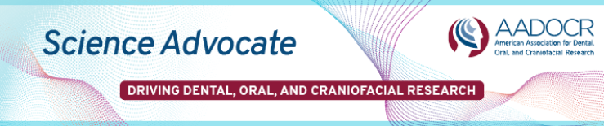
February 2024
Events | Advocacy | Publications | News
Funding Opportunities | Donate

Log in to my.iadr.org to access your member benefits! | IN THIS ISSUE…  - Register Now for Advocacy Day 2024!  - Don’t Miss the February 9th Housing Deadline for the IADR/AADOCR/CADR General Session  - Apply Today to the AADOCR MIND the Future Program

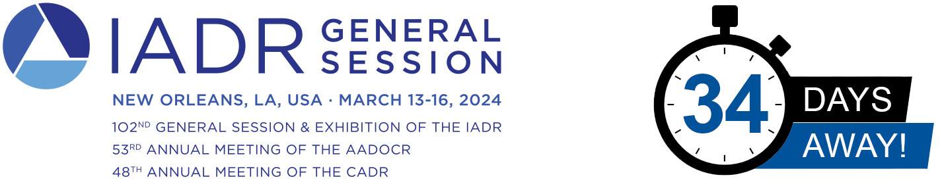
REGISTER NOW | MEETING AT A GLANCE | RATES & DEADLINES
In addition to thousands of abstracts, the 2024 IADR/AADOCR/CADR General Session & Exhibition will feature more than 85 Symposia, 19 Hands-on Workshops, nine Lunch & Learning tables, 22 Keynote Addresses, three Distinguished Lectures Series presentations, and seven Satellite Symposia compiled by IADR Scientific Groups and Networks.
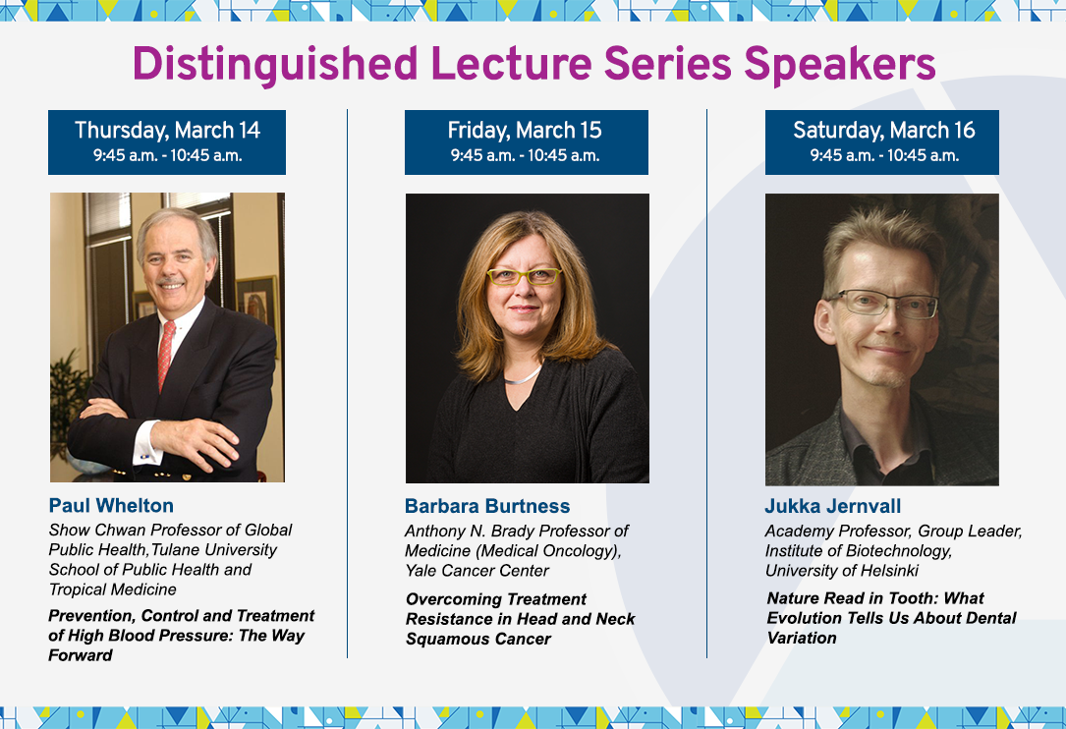
MEETING WITHIN A MEETING: Women and Dental, Clinical, and Translational Research
Join us on Thursday, March 14 and Friday, March 15 at 8 a.m. for the 2024 Meeting Within a Meeting, a special two-day event exclusively for IADR/AADOCR/CADR General Session attendees!

Description: Addressing the gap regarding the impact of dental disease on women requires a deliberate plan that weaves concepts of basic genetics, cellular and molecular physiology, and pharmacology into dental research.

Overall Goal: The goal of the 2024 Meeting Within a Meeting is to bring to light current dental research on women issues and display areas of interest and identify current gaps in knowledge.
Learn More.

HOUSING DEADLINE – FRIDAY, FEBRUARY 9TH

IADR has negotiated preferred rates with several hotels in New Orleans, all within a short distance to the convention center. Be sure to make your reservation with our official housing provider before February 9th! After this date the preferred rates may not be available.

Important: No one from any host hotels in New Orleans or the IADR will call you to solicit your hotel reservation. Travel agencies or housing bureaus that indicate they are representing IADR, AADOCR, CADR, the 2024 General Session in New Orleans, or any hotel or unaffiliated hotels, are perpetrating a fraud and are looking to acquire your credit card information. Reservations made by unaffiliated organizations may appear to be for lower rates, however they may be illegitimate, have unreasonable cancellation or change penalties, or may be completely nonrefundable.

Please be sure to make reservations directly through the official hotels. If you receive a phone call or email, DO NOT make your hotel reservations by telephone or email. Please be aware of and report any such unauthorized solicitations to Leslie Zeck at lzeck@iadr.org.

EXHIBITS & SPONSORSHIP

Promote your company’s latest advances to key thought leaders, researchers in the field, potential employees, students, and future researchers. Showcase your impact and influence on the industry by reserving your spot today! Learn more by visiting our Exhibits & Sponsorship page or email exhibits@iadr.org for more information.

Exhibit Dates and Rates:
Thursday, March 14 - Saturday, March 16 (9 a.m. – 5 p.m.)
Corporate: $5,750
Institutional, Government and Nonprofit: $2,875
__________________________________________________
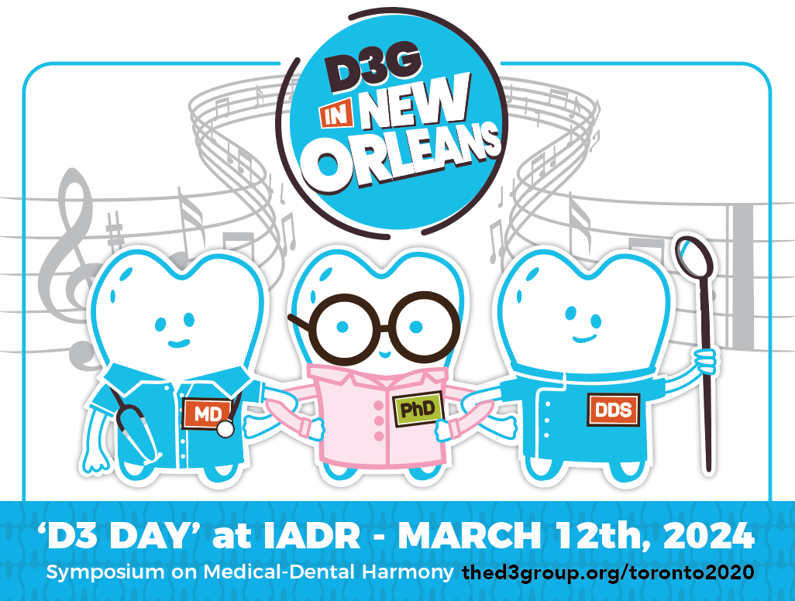
LEARN MORE
__________________________________________________

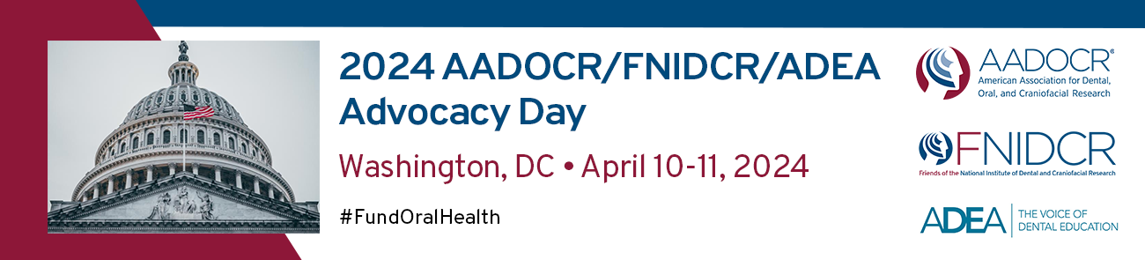

Register NOW!
This spring, join oral health researchers and dental school faculty and students from around the country at AADOCR’s 2024 Advocacy Day on Capitol Hill on April 10-11, 2024.

The annual event, in partnership with the American Dental Education Association (ADEA) and the Friends of NIDCR, provides an opportunity for the oral health science community to gather as one and deliver a unified message to Congress that they must protect federal funding for NIDCR and support oral health training and workforce programs.

Oral Health Research at Risk: Congress has yet to pass a budget for Fiscal Year 2024, but the spending bill proposed by the U.S. House would decimate the agencies and programs vital to our community by cutting the NIH budget by $2.8 billion, slashing ARPA-H by two thirds, and eliminating both the Agency for Healthcare Research & Quality and the CDC’s Office on Smoking and Health

We must demand that Congress reject these proposals, prioritize funding for scientific and medical research, and safeguard oral health programs. Help us raise our voice on Capitol Hill by attending Advocacy Day 2024. No prior advocacy experience is needed!

Registration closes on February 23 and only costs $25. For more information, visit the AADOCR Advocacy Day website.

Journal of Dental Research |  | JDR JDR Clinical & Translational Research
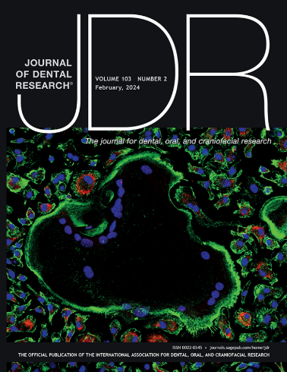 | Latest Issue  Submit a paper | 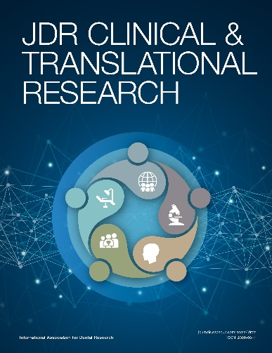 | Latest Issue  Submit a paper
Now Accepting Papers for JDR Special Issue on Advanced Imaging in DOC Research
The Journal of Dental Research will publish a special issue in 2024 highlighting innovations and applications of advanced imaging techniques for the benefit of dental, oral, and craniofacial (DOC) health. The guest editors are Dana Graves, Professor of Periodontics and Vice Dean, University of Pennsylvania School of Dental Medicine, and Sergio Uribe, Associate Professor and Lead Researcher, Department of Conservative Dentistry and Oral Health, Rīga Stradiņš University, Latvia.

Papers should be submitted to http://mc.manuscriptcentral.com/jdr no later than February 28, 2024 to be given full consideration.
Authors are required to include in their cover letter that their paper is being submitted for consideration for inclusion in the special issue on Advanced Imaging. Papers after this date will be considered for publication in the regular issue of the JDR.
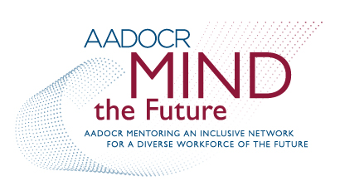
Apply Today to the AADOCR MIND the Future Program!
AADOCR’s Mentoring an Inclusive Network for a Diverse Workforce of the Future (MIND the Future) Program is designed to build a vibrant and inclusive community of investigators whose participation is vital to advancing dental, oral, and craniofacial research and improving the oral health of our nation.
The primary goal of this NIDCR-funded program is to establish a mentoring network that will support the professional development of a diverse pool of early career investigators, including those from groups identified as underrepresented in the biomedical, behavioral, clinical, and social sciences (see Notice of NIH’s Interest in Diversity).
Each year AADOCR selects a cohort of ten mentees for the program, each of whom commits to at least one full year of mentoring education and activities.
To learn more about the program, visit: https://www.aadocr.org/awards/mind-the-future The deadline for applications is May 6, 2024.
_________________________________________________

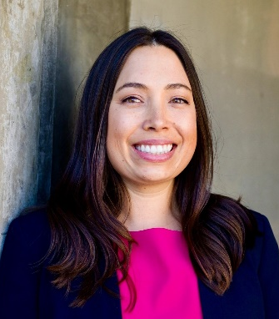
AADOCR Strides in Science
Jean Marie Star
University of California, San Francisco
“Being a part of AADOCR has exposed me to a wide array of research projects and endeavors from various institutions, enriching my understanding of the dental and oral health research landscape.” Read the full interview.

_________________________________________________
Earn CE Credits at the IADR Webinar & CE On Demand Library
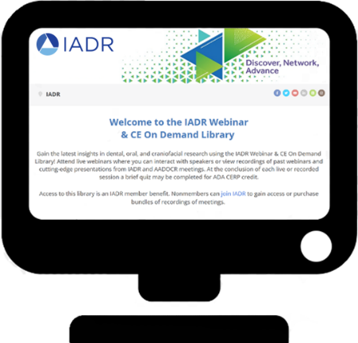
Featured Content:
- Basic Methods in Survey Design
- Peptides and Their Mimics: Next-generation Multifunctional Therapeutics?
- New Workforce Models of Oral and Dental Care to Support Global Oral Health and Universal Health Coverage
Submit a Webinar Proposal
AADOCR is currently accepting proposals for webinar ideas for 2023. Webinar proposals are subject to review and approval by the appropriate IADR committee. Webinar content should be organized around a cutting-edge topic and planned to be no more than 60 minutes (including a Q&A/discussion period). Any requests for additional time outside of the standard allotment of 60 minutes must be made at the time of submission for the committee to evaluate.
For more information and to submit your proposal, visit: https://www.iadr.org/form/webinar-series-proposal-form.
_________________________________________________
Show Your Support with AADOCR Gear
AADOCR represents you—the multidisciplinary scientists who work every day to advance dental, oral, and craniofacial research. Show your support with style!
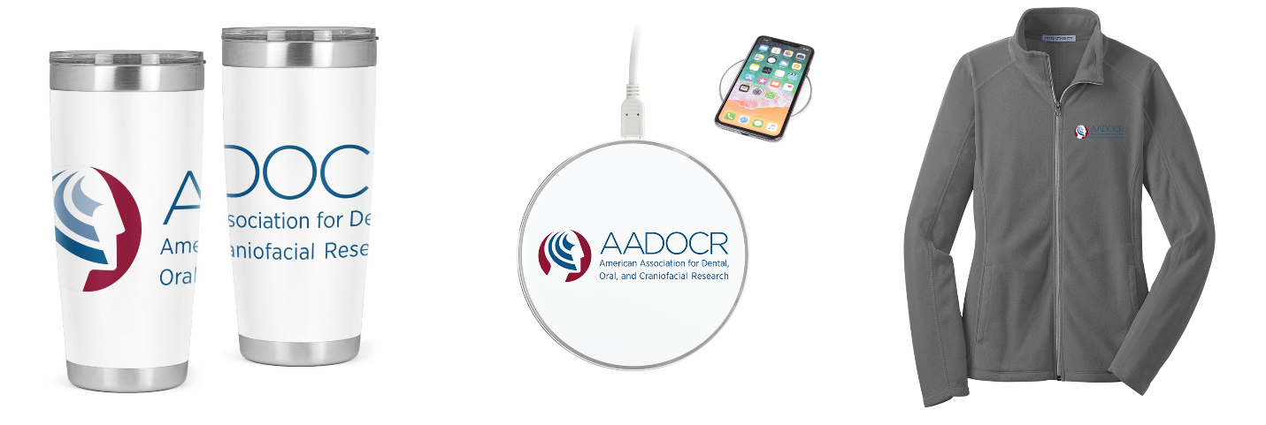
SHOP NOW!
_________________________________________________

Other Events
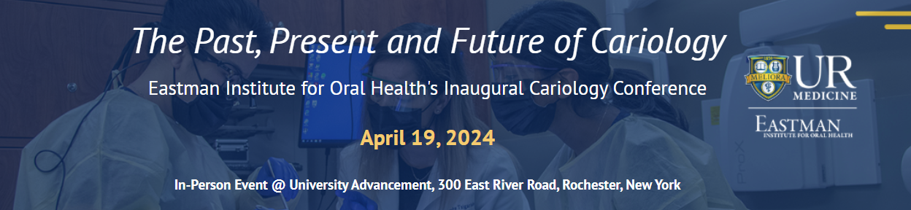
LEARN MORE
_________________________________________________
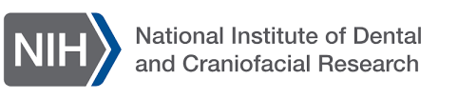
Putting Prevention Into Action: Prevention and Sealant Implementation Webinar
Join the NIDCR and the American Dental Association for a webinar series, Putting Prevention into Action, in observance of National Children’s Dental Health Month.
Date: February 28, 2024
Time: 1 p.m. – 2 p.m. EST
Location: Virtual
How to Join: Visit the registration page to register and receive a link to join the webinar.
This webinar will feature a panel discussion on the current landscape of dental sealant uptake and implementation, opportunities and challenges for school-based programs, parental concerns and education, and guidance for providers on evaluating the validity of published research. Health professionals are eligible to receive continuing education credit.
LEARN MORE

Symposium Series | Showcasing NIDCR Extramural Research: 75 Years of Excellence
Date: March 13-15, 2024
Time: Various (view the complete list)
Location: 2024 General Session of the IADR/AADOCR/CADR, Ernest N. Morial Convention Center, Room 294, New Orleans, LA.
How to Join: You must be a registered attendee of the 2024 IADR/AADOCR/CADR General Session. To register, visit the meeting webpage.
This symposium series is part of NIDCR’s yearlong 75th anniversary celebration and will highlight research conducted by NIDCR-funded institutions. Speakers will include those from different career stages, underrepresented groups in research, international sites, and those whose work is conducted at institutions outside of dental schools.
LEARN MORE
_________________________________________________

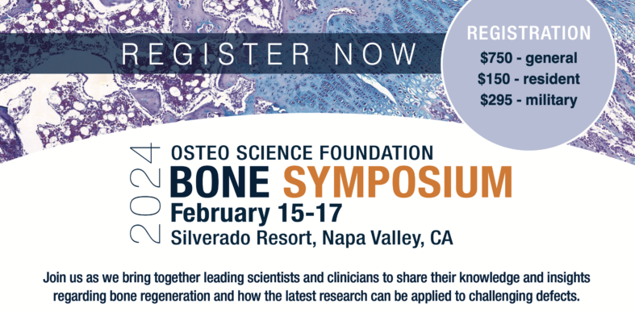
LEARN MORE
_________________________________________________

NIMHD Health Disparities Research Institute
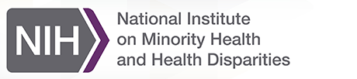
The Health Disparities Research Institute (HDRI) is a unique, week-long program that supports the research career development of promising early-career minority health and health disparities research scientists. Applications for the 2024 HDRI will be accepted from February 5 – March 11, 2024. HDRI will take place on August 6 – 9, 2024.
The program will feature:
- Lectures on minority health and health disparities research
- Mock grant review
- Seminars and small group discussions
- Opportunities to engage in sessions with NIH scientific staff
Applications will only be accepted from extramural scientists who meet NIH’s early-stage investigator (ESI) eligibility criteria. NIH and HHS staff, including persons in fellowships/training at NIH or an HHS agency, are not eligible to apply.
Visit the HDRI webpage to learn more about the program, eligibility requirements, selection criteria, and how to apply.

Latest NIH & NIDCR Funding Opportunities and Notices
The NIH and NIDCR provide many funding opportunities for scientists interested in dental, oral, and craniofacial research. Get the latest NIDCR news online. To view a full list of NIH funding announcements, visit: grants.nih.gov/funding/index.htm.

Notices of Funding Opportunities

Notice of Special Interest (NOSI): Administrative Supplement for Research and Capacity Building Efforts Related to Bioethical Issues (Admin Supp Clinical Trial Optional)
Release Date: January 2, 2024

NIDCR Notice of Participation in PAR-24-075 "Stephen I. Katz Early Stage Investigator Research Project Grant (R01 Clinical Trial Not Allowed)"
Release Date: January 4, 2024

NIDCR Notice of Participation in PAR-24-076 "Stephen I. Katz Early Stage Investigator Research Project Grant (R01 Basic Experimental Studies with Human Required)"
Release Date: January 4, 2023

Transformative Research to Address Health Disparities and Advance Health Equity (U01 Clinical Trial Optional)
Release Date: January 23, 2024

NIH Blueprint for Neuroscience Research: Request for Information (RFI) on the NIH Toolbox Assessments Conference
Release Date: January 24, 2024

Pre-Application Webinar for RFA-NR-24-004: Transformative Research to Address Health Disparities and Advance Health Equity (U01 Clinical Trial Optional)
Release Date: January 30, 2024

NIH Blueprint and BRAIN Initiative Diversity Specialized Predoctoral to Postdoctoral Advancement in Neuroscience (D-SPAN) Award (F99/K00 Clinical Trial Not Allowed)
Release Date: February 2, 2024
Featured Funding Opportunities
Research Supplements to Promote Diversity in Health-Related Research (Admin Supp - Clinical Trial Not Allowed) (PA-23-189)
Application deadline: May 8, 2026
NIDCR Director’s Postdoctoral Fellowship to Enhance Diversity in Dental, Oral and Craniofacial Research
Applications reviewed on a rolling basis.
FDA Funding Opportunities
View the current FDA Center for Tobacco Products funding opportunities.
NIH National Institute on Aging Funding Opportunities
Visit the NIA’s Grants and Funding web portal and view the current NIA funding opportunities.
Consider making a tribute gift and donating to the AADOCR New Investigator Research Development Fund! This program will support an annual $10,000 award to recognize original research by new investigators, which will help them fund their post-doctoral research, establish their laboratories, or prepare their research for publication.
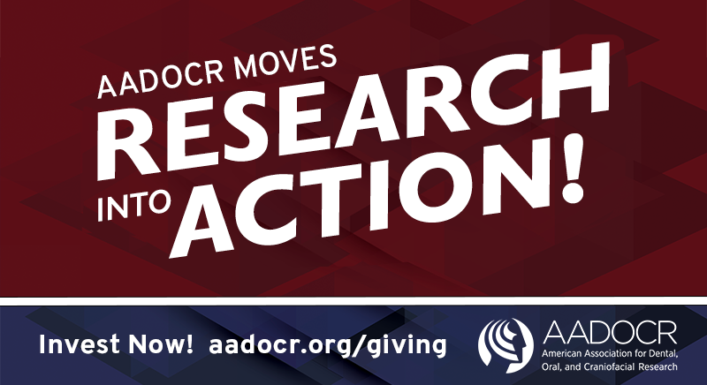

Science Advocate is a monthly e-newsletter exclusively for AADOCR members. If you have items you would like to include, please forward them to scienceadvocate@aadocr.org by March 1, 2024 for the next issue.
